Java File I/O (java.io) – Complete Explanation

1. What is Persistency?
Persistency means storing data permanently so that the data is not lost even after the program stops.
Example:
RAM (temporary memory)
↓
Program ends
↓
Data lost
To avoid losing data we store it in:
- Files
- Databases
- Cloud storage
In Java, storing data permanently in files is called File Persistency.
Java provides an API called:
java.io
This package provides classes to read and write data to files.

2. Understanding the Diagram (RAM vs File vs Database)
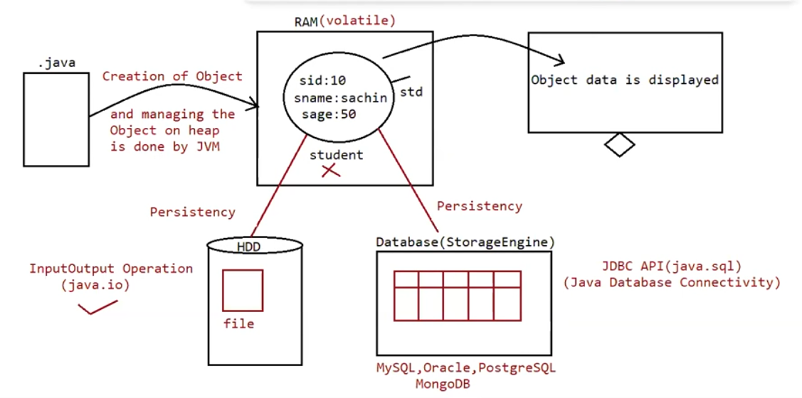

Program (.java)
↓
Object created by JVM
↓
Object stored in RAM (Heap Memory)
Example object:
Student
sid = 10
sname = sachin
sage = 50
This object exists only while the program runs.
When the program ends:
RAM is cleared
Object is destroyed
Data lost
To avoid losing data we store it in:
Option 1 — File System
Stored in
Hard Disk (HDD)
Example:
student.txt
Using
java.io

Option 2 — Database
Stored in
MySQL
Oracle
PostgreSQL
MongoDB
Accessed using
JDBC API (java.sql)

Summary
Storage | Technology
File storage | java.io
Database storage | JDBC

3. What is File?
A File is a collection of data stored in secondary storage (hard disk).
Example files
abc.txt
data.txt
students.txt
image.jpg
video.mp4

4. File Class
Java provides a class:
java.io.File
This class represents a file or directory path.
Important point:
The File class does not read or write data.
It is used for:
- Creating files
- Creating directories
- Checking file existence
- Getting file information
- Deleting files

5. File Object Creation
Example:
File f = new File("abc.txt");
What happens here?
Step 1
Java checks whether abc.txt exists in the current directory.
Step 2
If file exists
f → refers to that file
If file does not exist
No physical file is created
Only File object is created
So File object represents file name only.

6. Important Fact (Unix Concept)
Java File I/O is based on Unix philosophy.
In Unix:
Everything is a file
Examples
normal file
directory
device
socket
Because of this concept:
Java uses File class to represent both
File
Directory

7. File Class Constructors
Constructor 1
File f = new File(String name);
Represents file in current working directory
Example
File f = new File("abc.txt");

Constructor 2
File f = new File(String parent, String child);
Represents file inside another directory.
Example
File f1 = new File("abc");
f1.mkdir();
File f2 = new File("abc", "demo.txt");
Meaning:
abc/demo.txt

8. File Creation
To create file physically:
createNewFile()
Example
File f = new File("abc.txt");
f.createNewFile();

9. Directory Creation
mkdir()
Example
File f = new File("myfolder");
f.mkdir();

10. File Operations
File class provides operations such as:
exists()
isFile()
isDirectory()
length()
delete()
renameTo()
list()
Example
File f = new File("abc.txt");
if(f.exists()){
System.out.println("File exists");
}

Eg: FileClassExamaple

11. Writing Data to File
Java provides Writer classes.
Used for character data.
Example data
text
numbers
strings

12. FileWriter
Used to write character data to a file.
Example
FileWriter fw = new FileWriter("abc.txt");

FileWriter Constructors
Constructor 1
FileWriter(String name)
Example
FileWriter fw = new FileWriter("abc.txt");
Overwrites file.

Constructor 2
FileWriter(File f)
Example
FileWriter fw = new FileWriter(f);

Append Mode Constructors
If we want to append data instead of overwrite
FileWriter(String name, boolean append)
Example
FileWriter fw = new FileWriter("abc.txt", true);

13. FileWriter Methods
write(int ch)
Writes single character
fw.write(65);
Writes
A

write(char[] ch)
Writes array of characters
char[] ch = {'A','B','C'};
fw.write(ch);

write(String s)
Writes string
fw.write("Hello");

flush()
Ensures data in memory buffer is written to file.
fw.flush();

close()
Closes file stream.
fw.close();
Always close streams to release resources.

Eg: FileWriterExample

14. FileReader
Used to read character data from a file.
Example
FileReader fr = new FileReader("abc.txt");

15. FileReader Constructors
FileReader(String name)
FileReader(File f)

16. FileReader Methods
read()
Reads one character at a time.
Returns:
Unicode value
If end of file reached:
returns -1
Example
int i = fr.read();
while(i != -1)
{
System.out.println((char)i);
i = fr.read();
}

Eg: FileReaderExample

17. Why Character-by-Character Reading is Slow
Consider a file:
100 characters
Using FileReader:
read()
Each call reads only 1 character.
Process
read char
go to file
read next char
go to file
read next char
This happens 100 times.
This causes very low performance.

18. Better Approach
Read all characters into char array.
Example
File f = new File("abc.txt");
FileReader fr = new FileReader(f);
char[] ch = new char[(int)f.length()];
fr.read(ch);
for(char data : ch)
{
System.out.println(data);
}
Here
File → memory array
Then we process array.
This improves performance.

Eg: EfficientReadExample

19. Limitations of FileReader and FileWriter
Problems:
Problem 1
Line separator must be inserted manually.
Example
fw.write("Hello\n");
Different operating systems use different separators.
Windows → \r\n
Linux → \n
Mac → \r

Problem 2
FileReader reads character by character
Searching becomes slow.
Example:
Search for mobile number
9876543210
Need to read 10 characters.
For 10,000 numbers:
1 crore operations
Performance becomes poor.

20. Solution → Buffered Streams
Java provides buffered streams.
They improve performance by using memory buffer.
Classes:
BufferedReader
BufferedWriter

21. BufferedWriter
Used for writing character data with buffer support.
Example
BufferedWriter bw =
new BufferedWriter(new FileWriter("abc.txt"));
Important point:
BufferedWriter does NOT communicate directly with file
It communicates through
FileWriter

22. BufferedWriter Constructors
BufferedWriter(Writer w)
BufferedWriter(Writer w, int bufferSize)
Example
BufferedWriter bw =
new BufferedWriter(new FileWriter("abc.txt"));

